Jerusalem

May 03, 2020
119/2020

Food Balance Sheet 2018
The calculation of the food balance sheet provides information to policy makers on the amount of self-supply of food in the country and on the degree of dependence of the State of Israel on imports, according to the composition of the food. The information also helps in planning the subsidy policy of basic food products and making decisions regarding the amount of customs duty on imports, import quotas set by the Ministry of Agriculture, supplements of vitamins and minerals to basic products and more.
In 2018:
- The caloric value per capita of the food available to the population (offered in stores and markets) was 3,783 kilocalories, similar to 2017.
- Of the total 3,783 kilocalories available to every person in Israel, an average of 29% comes from bread and cereals, 18% from oils and fats, 13% from sugar, sweets and honey and 11% from vegetables, fruits and potatoes.
- The average quantities of food available to every person in Israel were as follows: 145 kg of fruit, 148 kg of vegetables, including melons, 164 kg of bread and cereals, 80 kg of meat and fish (boneless), 39 kg of potatoes and starches, 47 kg of sugar, sweets and honey, 181 liters of milk and milk products and 283 eggs.
- 99% of the grain supply in Israel is imported, as well as 92% of the fish supply, 68% of the legume, peanut and nut supply and 66% of the beef supply, whereas Israel produces 100% of the chicken and turkey meat and 91% of the dairy products.

Calorie supply 1950-2018
- The calories available to the public increased from 2,610 calories in 1950 to 3,783 calories in 2018
- In the relative share of dietary energy supplied by cereals and cereal products, there was a decrease from 48% in 1950 to 29% in 2018.
- In the relative share of dietary energy provided by meat, there was an increase from 4% in 1950 to 11% in 2018.
The summary of the food balance sheet shows that the caloric value of the food available to the Israeli population in 2018 reached 3,783 kilocalories (kcal) per capita per day.
The data refer to the quantity available to the public, i.e., the quantity offered, and not the quantity purchased by the public or the quantity consumed by the population.

Changes in energy supply for nutrition in the years 2017-2018
In 2018, the calorie supply per capita remained the same as in 2017, 3,783 kcal per day.
Table A – Main Food Groups Offered to the Public in 2017 and 2018
Kg per capita, unless otherwise noted
Commodity | 2017 R | 2018
Fruit (including fruit juices) * | 145 | 145
Vegetables (including melons) * | 154 | 148
Bread and cereals * | 169 | 164
Meat and fish (boneless) | 83 | 80
Mineral water and imported alcoholic beverages (liters) | 85 | 76
Potatoes and starches | 44 | 39
Sugar, sweets and honey | 41 | 47
Oils and fats | 29 | 28
Legumes, peanuts and nuts | 24 | 22
Eggs (units) | 267 | 283
Milk and dairy products (in milk terms) (liters) | 182 | 181
* 2017 data was revised

Nutritional Values per Capita per Day Compared to Recommended Dietary Allowance
Table B shows a comparison between the supply of nutrients, minerals and vitamins per capita per day in 2018 and the recommended dietary allowance.
The RDA (Recommended Dietary Allowance) is set by the Institute of Medicine (IOM) of the National Academies (United States), at a level that provides the recommended nutritional intake for the majority of the population, excluding populations with special needs, such as infants, pregnant or nursing women and senior citizens over 70 years of age.
Table B – Nutrients, Minerals and Vitamins per Capita per Day – Comparison Between the Supply and the Recommended Dietary Allowance, 2018
Nutrients, Minerals and Vitamins | Breakdown | Supply per Capita per Day in 2018 | Recommended Dietary Allowance (RDA)
Nutrients- (gram) | Carbohydrates | 503 | 130
Nutrients (gram) | Fat | 161 | Not yet set
Nutrient- (gram) | Protein | 115 | 50
Minerals (mg) | Calcium | 922* | 1,200
Minerals (mg) | Iron | 25 | 11
Vitamins (mg)) | Vitamin A (IU) | 7,248 | 2,667
Vitamins (mg)) | Vitamin B₁ (Thiamine) | 2.4 | 1.2
Vitamins (mg) | Vitamin B₂ (Riboflavin) | 2.3 | 1.2
Vitamins (mg)) | Vitamin B₁₂ (Niacin) | 33.0 | 15.0
Vitamins (mg)) | Vitamin C (Ascorbic acid) | 188.9 | 82.5
* Calcium added to milk products as a calcium supplement was not taken into consideration, due to the lack of data.
In all the parameters, except for calcium, the food supply per capita per day in 2018 was more than the recommended amount.

Minerals and Vitamins per Capita per Day
Cereals and cereal products are a major source of daily supply of minerals and vitamins per capita. Cereals and cereal products constitute 71% of the total supply of dietary fiber, 60% of the iron supply and 47% of the carbohydrate supply.
Sugar, sweets and honey provide 25% of the carbohydrate supply.
Milk and milk products provide 59% of the calcium supply.
Vegetables and melons provide 64% of the supply of vitamin A and 46% of the supply of ascorbic acid (vitamin C), fruits are 40% of the supply of ascorbic acid (vitamin C).

Index of Import Dependency
Diagram 1 – Degree of Israel’s Dependency on Imports for Main Commodities, 2018
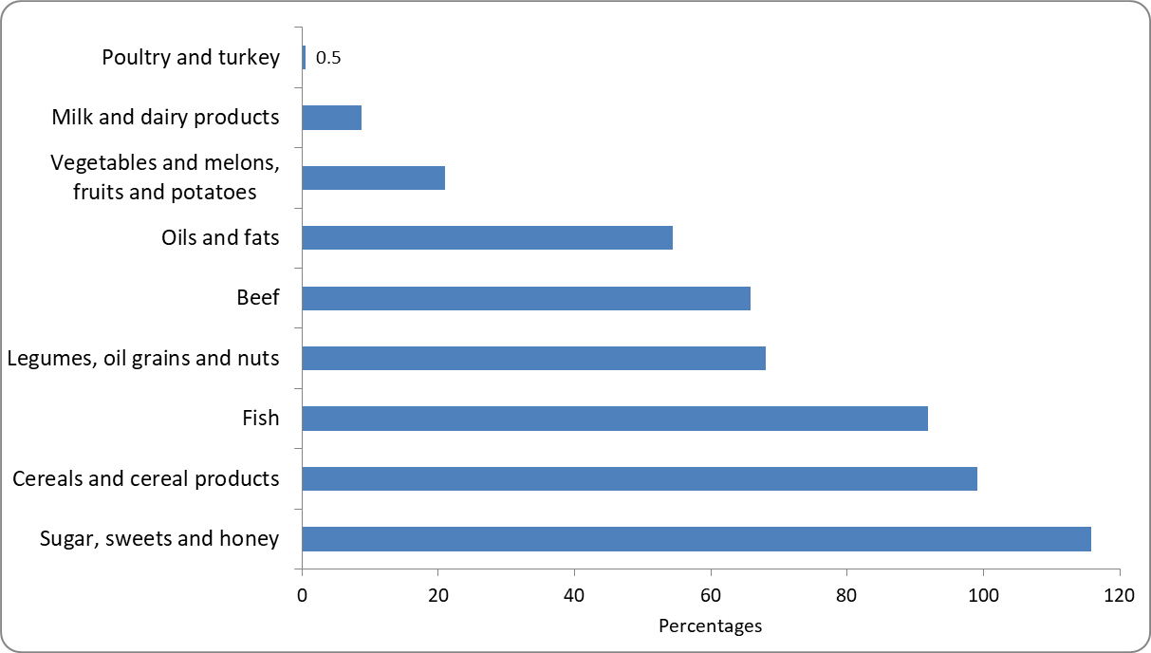
* When the index of import dependency is higher than 100%, it means that exports depend on imports. These cases occur, usually, if a particular component in the commodity for export is imported. For example: Exports of jams depend on imports of raw sugar used for their production.
Israel's dependence on imports of sugar, sweets and honey, cereals, fish, beef, legumes, peanuts and nuts is high.
The index of import dependency on imports of sugar and sweets is 116% and the dependency index on cereals and cereal products is 99%; 91% of Israel's fish supply depends on imports.
In contrast, Israel produces about 100% of the chicken and turkey meat available to the public, and the dependence on milk and dairy products is only 9%.

Calorie Supply 1950-2018
The composition of the food supply has undergone several changes over the years.
The data series of food sources over the years show the history of agriculture and diet in Israel, the changes in local food consumption habits that are reflected in the food supply and the changes in the import and export trends of food commodities.
Diagram 2 – Dietary Energy Supply – Main Sources, 1950-2018
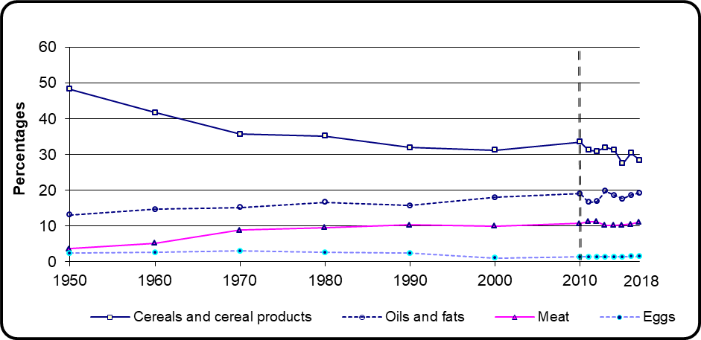
* As of 2010, the food groups have been changes, see Definitions and Explanations.
The most notable change in the dietary energy supply was a continuous decline in the relative share of dietary energy supplied by cereals and cereal products from 1950-2000 (from 48% to 31%). In 2000-2018 there were slight fluctuations over the years.
In the relative share of oils and fats there has been a gradual increase from 13% in 1950 to 19% in 2010. Since then, there have been slight fluctuations and no clear trend has been observed.
In the dietary energy supply from meat, there was an increase in 1950-2011 – from 4% to 11%. And since then, there has been stability in the relative share of meat (about 11% in 2018).
Diagram 3 – Animal Protein Supply per Capita per Day, 1950 and 2018
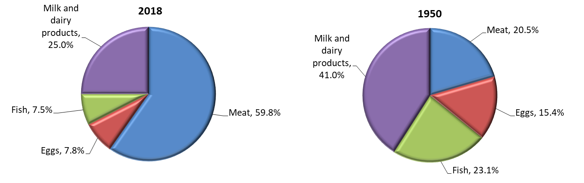
Over the years there has been a change in the sources of animal protein supply. The relative share of meat has tripled, while the relative share of other food sources - milk and dairy products, eggs and fish decreased.

Calorie Availability per Capita per Day, International Comparison
Diagram 4 – Calorie Availability per Capita per Day, 2017 – Selected Countries
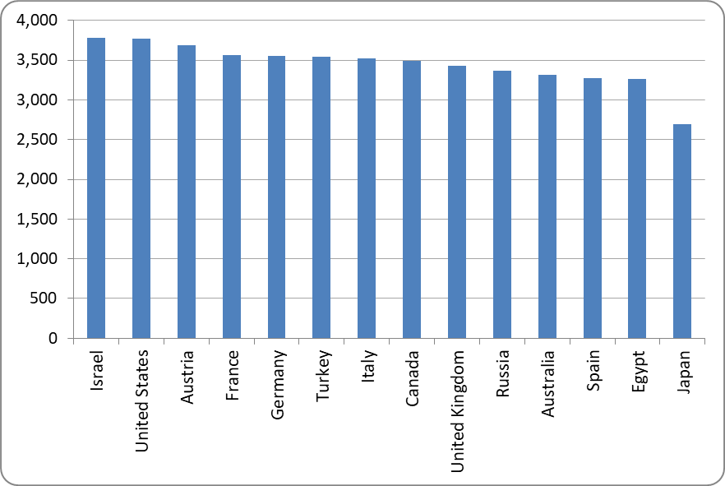
In Israel, the availability of calories is slightly higher than in all the countries surveyed. The gaps between the availability of calories in Israel and the other countries, which are larger, have narrowed greatly over the years.

Definitions and Explanations
The food supply calculation includes the natural content of vitamins and minerals in commodities and does not include food supplements marketed separately or food additives such as calcium in milk. Moreover, imported high-calorie foods are not included, for example, high-calorie sport drinks.
The calculation of the food balance sheet provides information to policy makers on the amount of self-supply of food in the country and on the degree of the State of Israel’s dependence on imports, according to the composition of the food. The information also helps in planning the subsidy policy of basic food products and making decisions regarding the amount of customs duty on imports, the import quotas set by the Ministry of Agriculture, supplements of vitamins and minerals to basic products and more.
Following a re-examination of the Food and Agriculture Organization (FAO) guidelines, since 2010 the food groups "Cereals and cereal products", "Vegetables and melons" and "Fruits" have been changed:
- "Corn" was transferred from the "Vegetables and melons" group to the "Cereals and cereal products" group.
- "Grapes" does not include grapes used for locally produced wine.
Therefore, caution should be exercised when comparing to data previous to 2010.
Import Dependency Ratio
The Import Dependency Ratio (IDR) provides information on the degree of dependence of the State of Israel on food imports.
It is calculated according to the international definition of the International Food Organization (FAO). The ratio does not take into account the change in inventory, as the inventory is not marked by its source - domestic production or imports - and it is assumed that the food source is similar over the years.
The calculation is made on the existing supply, before deducting industrial uses, depreciation, seeds and animal nutrition.
100 * Imports = Import Dependency Ratio
Exports - (imports + production)

Including watermelons and melons.
As of 2010, there was a change in the definitions of cereals and cereal products, fruits and vegetables, see Definitions and Explanations.

